Linux command for process

1) top: The top command is the traditional way to view your system’s resource usage and see the processes that are taking up the most system resources. Top displays a list of processes, with the ones using the most CPU at the top.

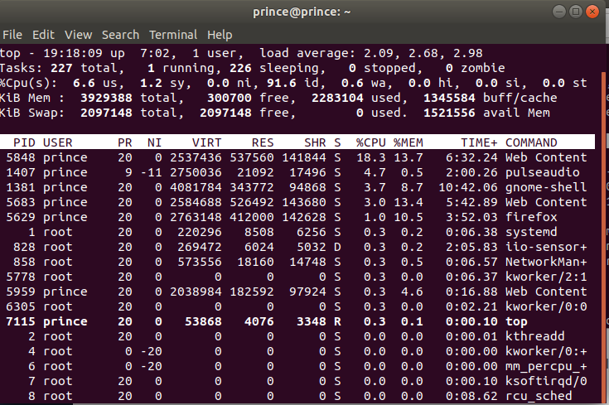
To exit top or htop, use the Ctrl-C keyboard shortcut. This keyboard shortcut usually kills the currently running process in the terminal.

2) htop: The htop command is an improved top. It’s not installed by default on most Linux distributions — here’s the command you’ll need to install it on Ubuntu:

sudo apt-get install htop
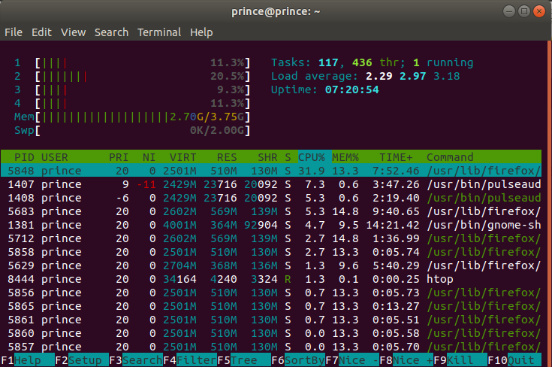

3) ps -A : The ps command lists running processes. The following command lists all processes running on your system:

ps -A

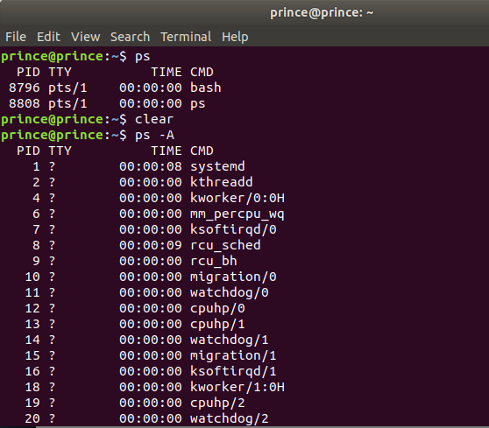

4) ps -A | less: ps -A may be too many processes to read at one time, so we can pipe the output through the less command to scroll through them at own pace.

ps -A | less:

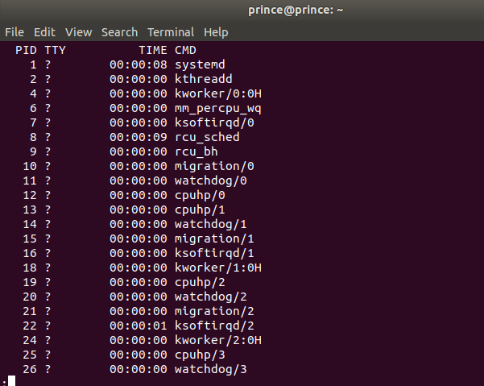

Press q to exit when you’re done.
5) ps -A | grep : We could also pipe the output through grep to search for a specific process without using any other commands. The following command would search for the Firefox process:

ps -A | grep firefox
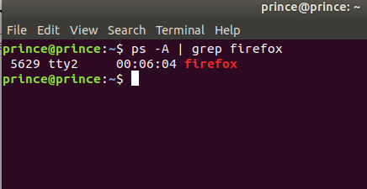

6) pstree:

The pstree command is another way of visualizing processes. It displays them in tree format.
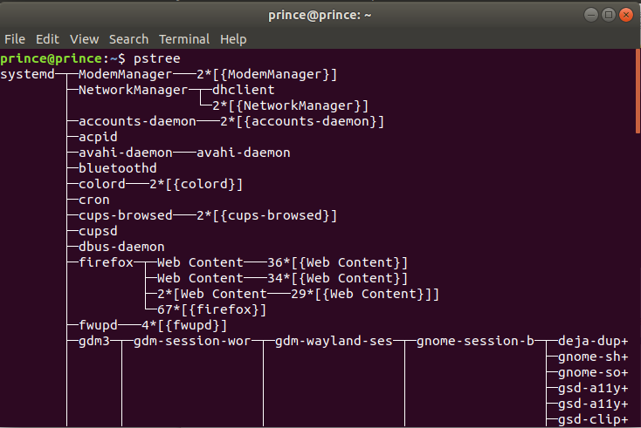
7) kill :
The kill command can kill a process, given its process ID. You can get this information from the ps -A, top or pgrep commands.
kill PID
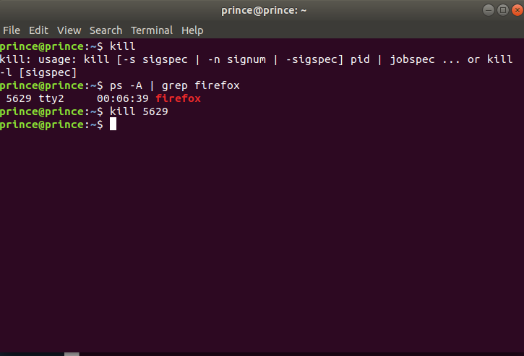
8) pgrep :

Given a search term, pgrep returns the process IDs that match it. For example, you could use the following command to find Firefox’s PID:
pgrep firefox
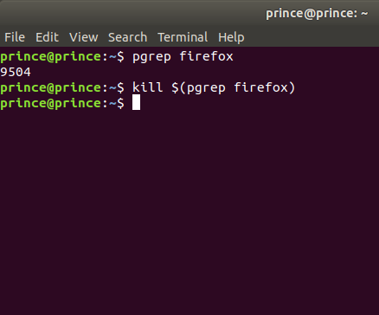

9) pkill & killall :

The pkill and killall commands can kill a process, given its name. Use either command to kill Firefox:
pkill firefox
killall firefox
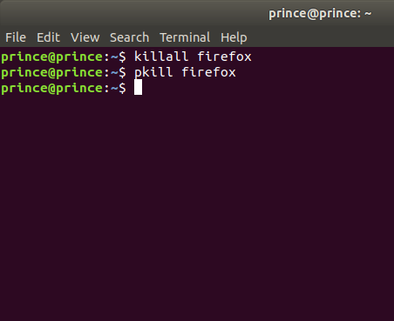

10) renice:
The renice command changes the nice value of an already running process. The nice value determines what priority the process runs with. A value of -19 is very high priority, while a value of 19 is very low priority. A value of 0 is the default priority.
The renice command requires a process’s PID. The following command makes a process run with very low priority:
renice 19 PID
